Android Formula Calculator App



* Brett Bertrand

Contents

Project Proposal 3

Project Summary 3

Personal Goals 3

Audience 3

Design Vision 4

Functional Requirements 5

Technical Requirements 5

Computer Application Code 6

Testing 7

User Documentation 8

# Project Proposal

## Project Summary

I plan to make a fully functioning app for the android using android studios. I will be writing in Java, which I am currently learning. This app will be centered on a quick and easy method to solving an equation that the user inputs without them having to actual type the equation. Essentially they’ll be given a large list of types of equations or measurements they’re trying to solve for. The app will then ask what information they have in which to solve the equation. Since there are multiple different equations that can solve for the same type of measurement, the app will have to determine which one to use based off of this input. If there isn’t enough information they will be informed. If there is they will be issued an answer as well as the correct SI units.

## Personal Goals

I just want to make an app that isn’t basic or easy. I want to challenge myself to make an app that is the best I can make it within the time that I have. However, I like the idea of my app being useful and this would be highly relevant if I had made it last year to help me with my physics class this year. This is like a test to me. I figure if something as small as this is too difficult or rigorous, then it’s probably not the thing I want to do for the rest of my life.

## Audience

This project will be geared toward students in general taking any kind of math class (specifically physics). Some students in my physics class complain about how hard it is to set up the equations and so this app will completely fix that. Others complain that it’s too difficult and while this may not teach them much, they’ll be able to get answer without too much thought. There are even a few who say that it’s so easy and it’s tedious to have to set up all the equations and then to solve them. They already know how to do it, why should they have to waste so much time practicing something they know like the back of their hand. This app would save them loads of time and effort they could be putting towards something else. This app will include some physics, algebra, geometry and even some lower level math type equations. This would mean that it would be most useful to 5th through 11th graders.

# Design Vision

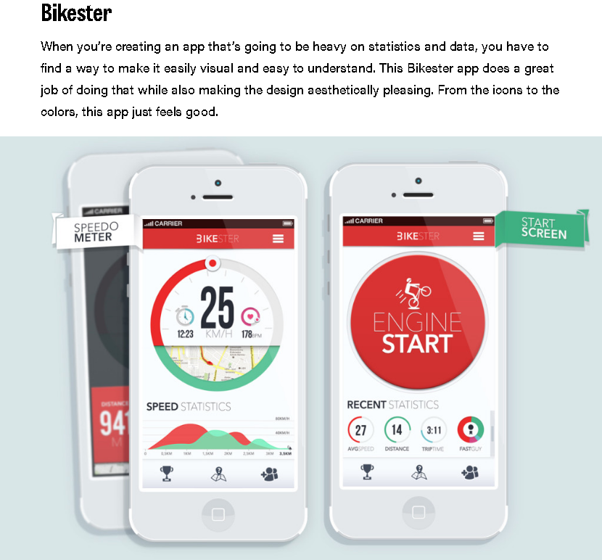

The Bikester app is a perfect example of how I’d like my app to look. I want it to look smooth, appealing and simple so that it’s easy for the user to use. I don’t want them to get confused with how to get it to work or get bored of the layout so much that they decide to just write it themselves because it’s something easier to look at. I want it to draw them in and make it feel as easy to use as possible. I like the idea of the big button in the middle. Maybe I could use it as a “Calculate” button at the end.

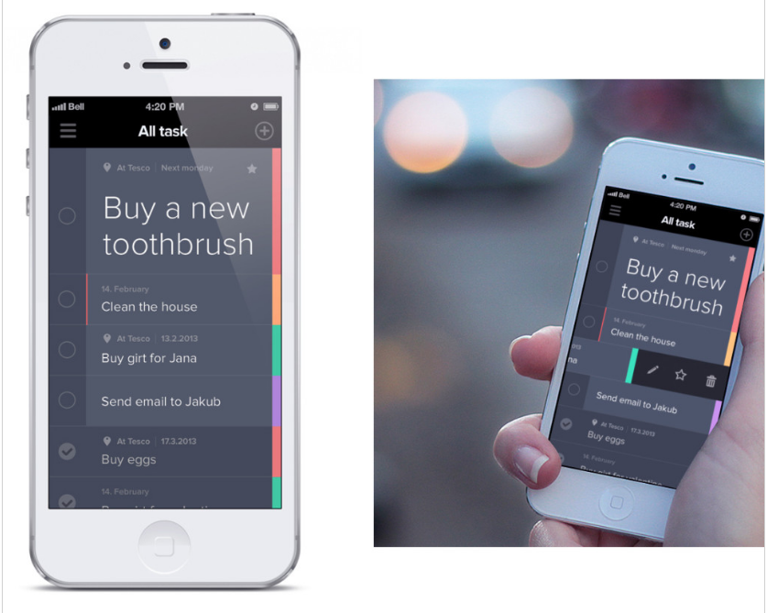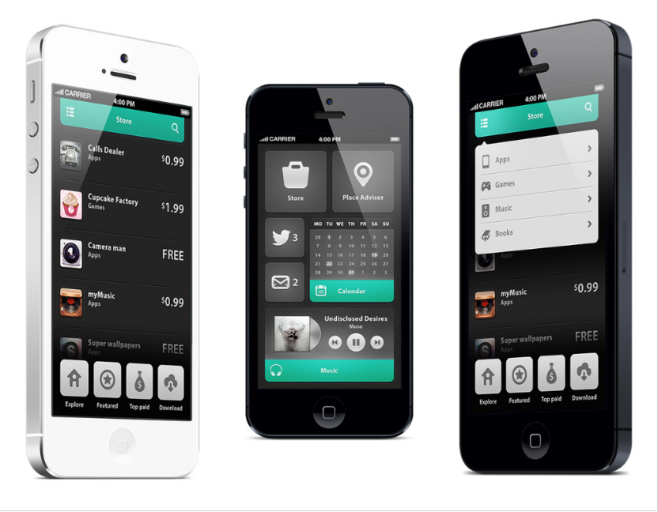

## Functional Requirements

### Overview

The Primary purpose of this app is to make calculations for the user with little effort by the user. Whether it’s a small calculation that the user is making over and over again or it’s a more complex calculation that the user is having a tough time formulating in their calculator, the app will make these tasks much simpler and easier. This app will serve to ease the stress on the users mind by giving them a solution based on the information they know.

It also serves as a faster means of finding a solution. This is especially useful if the means of finding the solution are known or second nature. This app would serve quicken this process and decrease the tediousness of the task.

### Scenarios

This student is really struggling in his classes lately. He is extremely stressed out and is finding it hard to focus and get anything done. He’s slacking on his homework as a result. It’s getting close to the end of the Unit in his math class and he hasn’t turned anything in. He feels confident in the material but thinks doesn’t know if he will be able to get all of that work he’d missed done before he has to turn it in and study at the same time. So he downloads this The Easy Formula Calculator. He uses it to get through all of his homework extremely fast. He ends up with more than enough time to study and as a result does well on his test the next day and is able to turn in all of his work.

Now, this student is a straight A, honor student with a particular gift for math. She is extremely good hearing and comprehending what the teacher is teacher is teaching her. She consistently gets high A’s on all her tests and finds it unnecessary for her to do the homework since she already knows what she’s doing. However, it’s still a required 20% of her overall grade that she needs to do even if she feels it’s a waste of time. That’s why she uses this app as a solution to speed up the process. She has to do it but doesn’t need to take the time to do each problem individually. This app would allow her to quickly and easily get through the homework allowing her more time for things more worth her time.

### Non Goals

* I will not implement an SI unit conversion function into the application
* I will not do every formula (around 10-15 for this product)
* I will not attempt to add a search function to find the correct formula (a simple scroll list will be used instead)
* I will not make a sideways version for when you turn your phone sideways
* I will not add the top information (cell coverage, time, battery life)

### Flow Chart of Screen

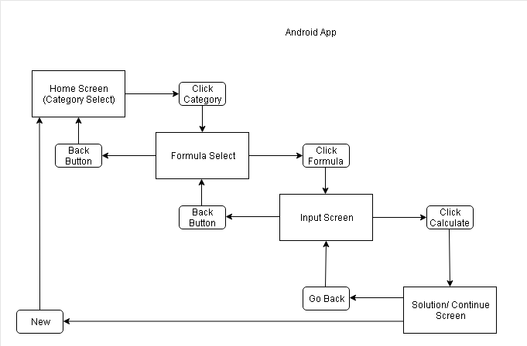

### Screen by Screen Specification

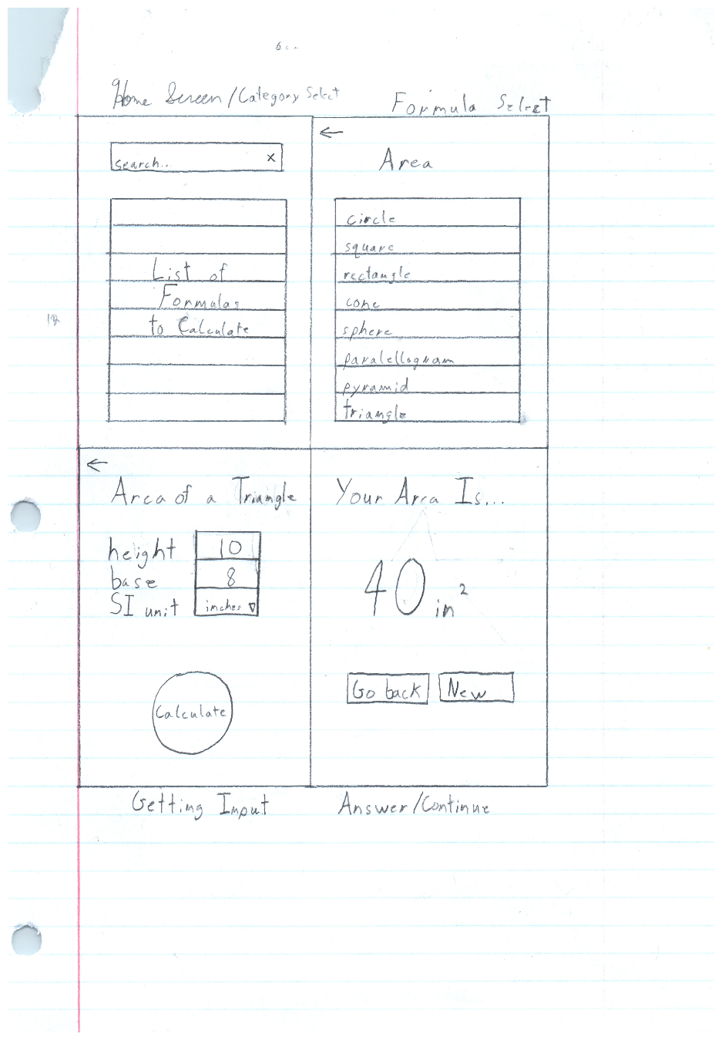

## Technical Requirements

### Data Dictionary

|  |  |  |
| --- | --- | --- |
| **Variable** | **Data Type** | **Purpose/Explanation** |
| Formula Category | String | The name of the section of formulas that come up |
| Formula Name | String | The name of the formula being used |
| Length | Double | An input measurement |
| Height | Double | An input measurement |
| Width | Double | An input measurement |
| Base | Double | An input measurement |
| Leg 1 | Double | An input measurement |
| Leg 2 | Double | An input measurement |
| Mean | Double | An input measurement |
| Standard Deviation | Double | An input measurement |
| Z-score | Double | An input measurement |
| Sample Size | Double | An input measurement |
| Population Size | Double | An input measurement |
| Acceleration | Double | An input measurement |
| Speed/Velocity | Double | An input measurement |
| Radius | Double | An input measurement |
| Angle 1 | Double | An input measurement |
| Angle 2 | Double | An input measurement |
| Gravitational Acceleration | Double | An input measurement |
| SI Unit | String | Selected unit of measurement |
| Continue? | Boolean | Do you want to start over? (Yes/no) (True/False) |
| Back? | Boolean | Do you want to go back |
| Answer | String | The answer along with its specified SI value |

One of the primary Data Types I’m using in this formula calculator application are Doubles. “The Double class wraps a value of the primitive type double in an object.” My reasoning behind using this data type is that it is capable storing both integer and decimal values, which is extremely important when it comes to solving mathematical equations. As a result the input values stored by the user will be exact and therefore the answer will be more accurate. If I were to use an Integer type instead, any decimal value input would be lost and the answer would be calculated accordingly.

Another primary Data Type I’m using is the String. A String stores sequences of characters (number values, letters, and symbols) under the type String. This will allow me to store any input from the user when it can allow for any type of character. For example, what formula do you want to use? The question is prompting input from the user that will allow the application to pick from a list of “Formulas” for one that matches to decide where to go next. Since the formulas that the user can pick from are full words making impossible for me to use an integer or double type leaving a String as the perfect fit.

The last Data Type I’d consider to be a primary would be a Boolean. This will be used to for the user to control the ebb and flow of the screens outside of the natural algorithm of the code. A Boolean class wraps a value of the primitive type boolean in an object. What this data type does is it evaluates other data and statements to come out with either a True or False value which is then stored. In the case of the app, it will be used when asking questions or to allow the user to go back a screen. For example the back button will have a False value till it is clicked on in which it will be True and will execute a code to take the user to the previous screen.

### Algorithm Design

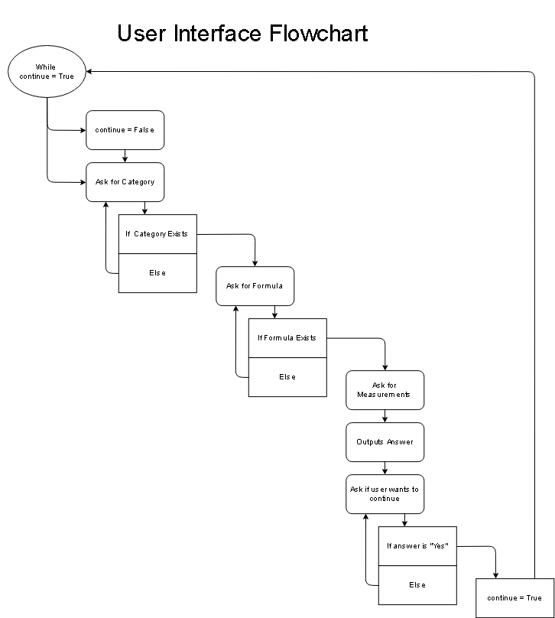

The Purpose

Pseudo Gathering Input

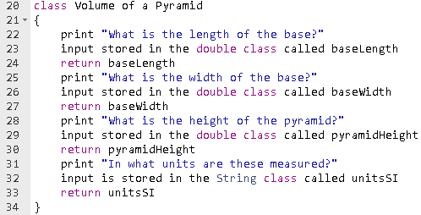

Pseudo Calculating Answer

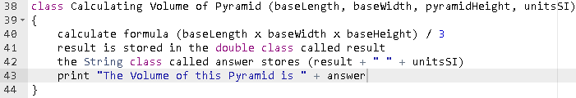

# Computer Application Code

# Testing

# User Documentation